ACCELERATOR SURVEY AND alignment AT THE ITALIAN

National CENTER FOR ONCOLOGICAL HADRONTHERAPY
D. Bianculli, CNAO, Pavia, Italy
F. Sgamma#, LNF-INFN, Frascati, Italy
Abstract
The CNAO (Centro Nazionale Adroterapia Oncologica) is the first medical accelerator facility for deep hadrontherapy with C⁶⁺ and protons in Italy. Two Electron Cyclotron Resonance (ECR) ion sources produce a beam injected into a LINAC where it is accelerated at 7 MeV/u. A 78 m circumference synchrotron stores and accelerates carbon ions beam up to 400 MeV/u and protons up to 250 MeV. The beam extracted from the synchrotron can be delivered on four lines in three treatment rooms: the central one has two beam lines, one horizontal and one vertical; the laterals have an horizontal beam line each. The beam path from sources to patient, despite being compact with respect to similar accelerator complex, is rather long and many optical components contribute to the beam shaping. All these components need to be accurately aligned in a well defined position in order to accomplish their tasks. This paper shows the alignment method, discusses of the survey instruments and software used for positioning both beam diagnostic devices and magnets.

InTRODUCTION
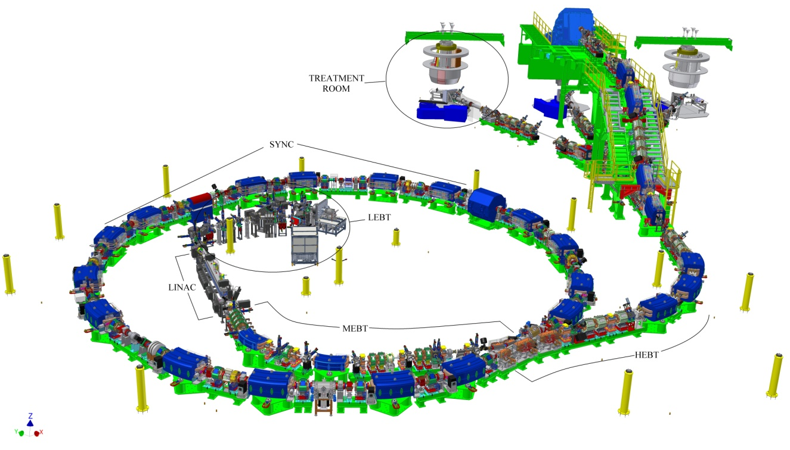
The particles accelerator is composed of 5 main sections: LEBT (Low Energy Beam Transfer), LINAC (Linear Accelerator), MEBT (Medium Energy Beam Transfer), SYNC (Synchrotron) and HEBT (High Energy Beam Transfer). A 3D sketch of the accelerator is depicted in fig. 1.

#francesco.sgamma@lnf.infn.it

The tighter tolerances on alignment, which are required for the SYNC’s conventional magnets, are summarized in table 1.
Table 1: SYNC Magnets alignment tolerances (RMS)
Magnet type | Longitudinal [mm] | Radial [mm] | Vertical [mm] | Roll [mrad]
Dipole | / | ± 0.15 | ± 0.15 | ± 0.15
Quadrupole | ± 0.5 | ± 0.15 | ± 0.15 | ± 0.15
Sextupole | ± 0.5 | ± 0.15 | ± 0.15 | ± 0.15

ALIGNMENT NETWORK
The most part of the machine is installed in a main hall 43m long and 35m large, where beam-lines tracking on the floor and alignment network installation started on July 2006. The network has been designed both for optical and electronic instruments: it is composed by 15 pillars, 20 ground sockets and 18 wall sockets (see fig.2).

Figure 1: General layout of CNAO: the yellow pillars are part of the alignment network

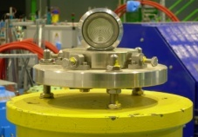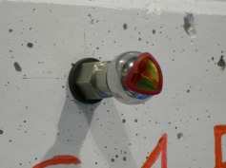
Figure 2: Network references: from left to right
a) pillar b) ground socket c) magnetic wall socket

All the references have been realized to be adjusted to their nominal position, in such a way that one pillar and one ground socket are aligned with a straight line of the accelerator sector, where possible. Distance and horizontal angle measurements between pillars and ground sockets in the synchrotron hall have been performed by a Leica TDA5005 total station. All data have been processed by STAR*NET, a software for least square adjustments [1]. 373 measurements performed from 7 different pillars have been bundled. In fig. 3 all the points measured are visible: P1 is the central pillar and the direction P1-P11 is the SYNC symmetric axis. The absolute reference system is given by P1 as origin, P1-P11 as horizontal direction and the gravity force as vertical direction.
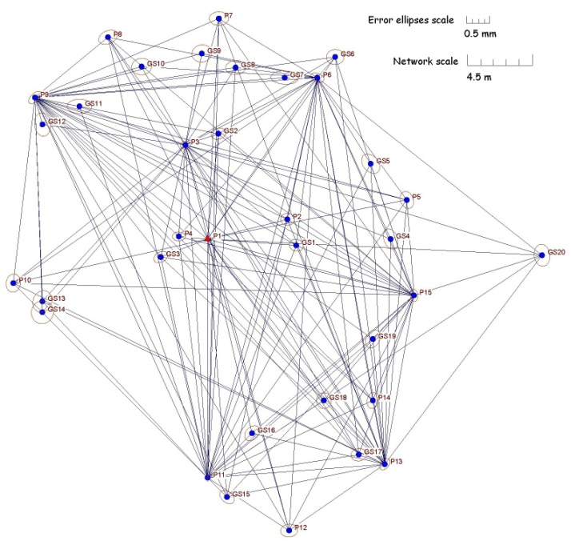
Figure 3: Network measurements.

In November 2006, 2D coordinates of all network points were completed adding levels measurements of pillars and ground sockets respect to central pillar P1 by means of an optical auto-level Leica NA2 equipped with plane parallel plate micrometer GPM3.
Since May 2007 a laser tracker system LTD500 increased the speed and accuracy of measurements. Eleven free stations well distributed inside and outside the synchrotron ring have been bundled using the industrial software Axyz [2]. Each station has at least 4 or 5 points in common with the previous one. Bundling 135 points the reachable total RMS is around 60 μm with a maximum pointing error exceeded of 0.25 mm. Levels of all pillars have been measured directly by means of NA2 and referred to P1, when the range were less than 10mm; otherwise TDA5005 was necessary using the built-in electronic level.
The comparisons between two sets of network surveying show that the hall’s deformations, during last three years, are not negligible. Most part of displacements are along vertical direction in the order of some mm/year. These are due to building settlement caused by civil engineer works during installation of accelerator components. Nevertheless, for machine commissioning reasons, it was not possible to postpone the installation till the settlement building.
Finally we had to deal with the problem of line of sight: the 2 meters thickness radioprotection wall between SYNC and treatment rooms reduces visibility apart a 50x50cm² window for vacuum chamber. Three 1.5” CCR holders (Corner Cube Reflector) are positioned at beam height through laser tracker in the SYNC hall. A TDA5005 mounted on a wooden tripod and equipped with a measuring slide is aligned along nominal beam axis in each treatment room. Additional points can therefore be positioned to materialize the beam line also in treatment rooms. The job is completed with the surveying of wall sockets network.

FIDUCIALISATION

Magnets

Quadrupoles and sextupoles
From the alignment point of view it is mandatory to know the offset between mechanical and magnetic centre for multipole magnets. The method used is the rotating coil bench, which is the commercial version of the measurement system developed at CERN for the multipole measurements [3][4]. In fig. 4 a side view of the machine illustrates the main parts.

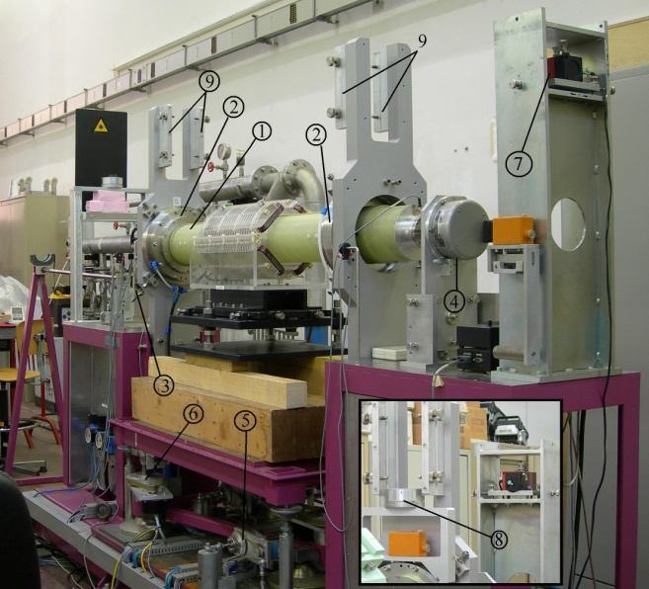
Figure 4: Side view of Multipole Measurement System (Danfysik) with an air core quadrupole - (1) rotating coil, (2) air bearings, (3) DC motor, (4) angular encoder, (5) magnet positioning system consisting of magnet platform, horizontal movement gears and motors, (6) vertical movement gears and motors, (7) laser for alignment, (8) photo detector with Taylor Hobson ball, (9) calibration support

An alignment table is precisely positioned on top of each magnet by means of three removable supporting cylinders leaning on sextupoles machined surface and on quadrupoles customized aluminium plates. The table is equipped with two centesimal measuring slides and Taylor-Hobson spheres holders, as can be seen in fig. 5. The sphere centres are the magnet reference with respect to the laser beam of the rotating coil system, placed parallel to the rotating coil axis in a vertical plane at a distance of 350 mm from it.
The magnet is placed on the movable support of the rotating coil system and aligned by mean of laser beam. After magnetic measurements, the system provides three geometrical data: horizontal and vertical displacement of magnetic centre with respect to initial position and the roll angle, that is the rotation along the longitudinal axis. Since the system measures only the integrated magnetic field, the magnetic centre longitudinal position is unknown; anyway mechanical and magnetic axis can be reasonably supposed to be parallel and magnetic centre to lie in the transversal middle plane.
The mechanical axis is simulated with a half-cylinder with two precision ribs, leaning on the surfaces of the magnets lower poles [5]. Mechanical qualification job data are finally integrated with magnetic centres measurements by means of Axyz.

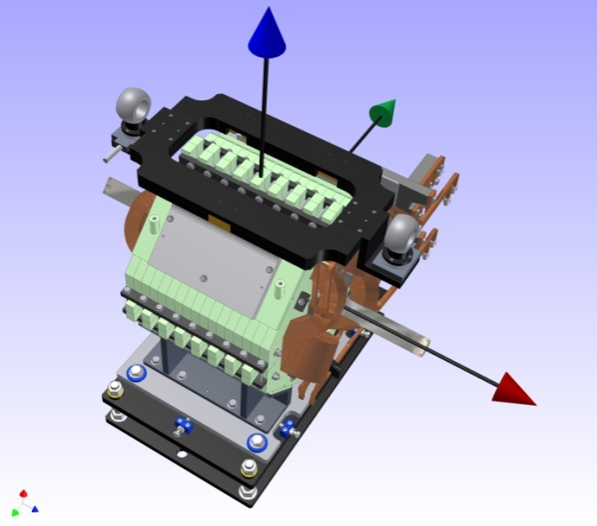
Figure 5: 3D sketch of a HEBT quadrupole with half-cylinder inserted between the poles and the alignment table on top

SYNC dipoles
On the upper yoke of any of the 16 SYNC dipoles 4 CERN socket-type fiducials are installed. Two of them are positioned along two straight beam-lines in entrance and exit. The choice of this targets holder gives the advantge of measuring the transversal shift of quadrupoles and sextupoles with respect to the nominal magnetic vertical plane directly, simply using a theodolite mounted on tribrach with auto-centering pin.
Each dipole is fiducialized measuring upper and lower yoke at entrance and exit of the magnet by means of LTD500, and taking into account only the fiducial points nominal geometry. Results of magnetic measurements are useful for sorting dipoles for installation in SYNC and HEBT [6].

Beam Diagnostics devices

Profile grid
A profile grid is aimed to measure beam transversal profile in both horizontal and vertical planes. It can also allow to get rough estimations on beam intensity variation. Grid monitor consists in a given number of thin wires, arranged as a harp and is used in the LEBT and MEBT lines where the beam is pulsed [7][8]. The detector is mounted on a pneumatic actuator and the whole device is inserted into a vacuum tank. The qualification purpose is to know exactly where the centre of the grid respect to the nominal beam-line is.
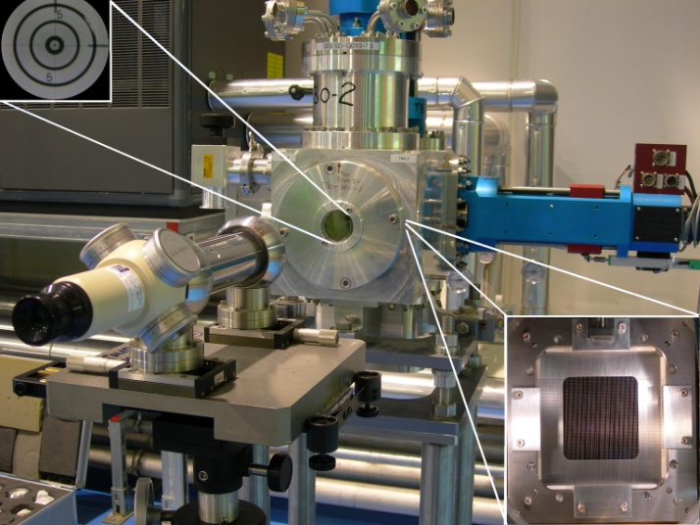Figure 6: Taylor-Hobson telescope and vacuum tank test bench equipped with diagnostic; at left a zoom view of glass target and at right the grid monitor with wires

A micro-alignment telescope of Taylor-Hobson is positioned along the tank beam-line which is the virtual line passing through the centre dots of two glass targets at the tank’s entrance and exit. A very precise alignment is possible using levelling screws of tank and measuring slides of the telescope table. After the telescope crossline is perfectly coincident with the centre dots, the detector is moved and the offset checked. A customized mask, applied on the detector frame, locates the square of wires at the centre. Fine regulations screws on the actuator’s frame can finally align this square with the telescope crossline. Fiducials on the tank are finally measured respect to the telescope cylinder and glass targets, by means of laser tracker. The overall accuracy obtained is 0.1 mm, which is the same order of magnitude of wire’s diameter according to the beam diagnostic constraints.

Pickups
Along the synchrotron 20 capacitive pickup detectors are installed: 9 for the vertical plane and 11 for the horizontal one. Pickup detectors, also called Beam Position Monitors (BPM), measure the beam centre of mass transverse position in a not-interceptive way. A pick up detector is a metallic box divided in two halves and inserted into a metallic body which is grounded. The capacitive coupling between body and the electrodes determines the signal generation when the particles bunch passes through the detector [9].
The qualification job is divided into two phases: measuring the electrodes mechanical centre first and the electrical centre after.
Each pick-up was measured through a Coordinate Measurement Machine (CMM) by the company responsible of the production. On each pick-up a survey table, consisting of two orthogonal planes, is screwed on a reference plate and can be repositioned using two precision pins (see Fig.7).
For the electrical centre measurements, a metallic wire was stretched along the longitudinal direction and moved in transversal directions. Injecting a sinusoidal signal into the wire a signal is induced on the pick-up electrodes. Before each measurement the electrode’s mechanical centre was found, in order to zero the wire encoder and thus being able to determine the electrical centre respect to the mechanical one.
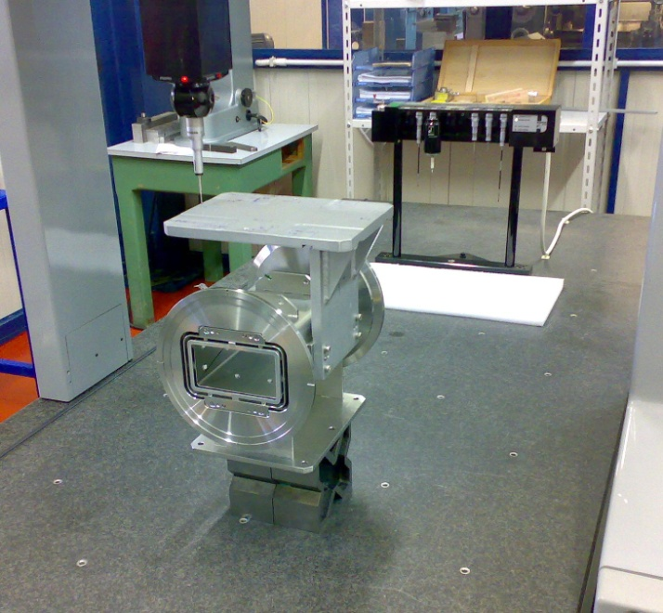
Figure 7: A pick-up and its survey table on the granite floor of a CMM

TV- screen
Two monitors, consisting of a luminescent screen read-out by a radiation-hard camera, are installed in the synchrotron injection/extraction vacuum chamber to measure transverse size and position of the beam injected into the SYNC ring and after the first turn. Screens are made up of zirconia material. On each screen, which is driven by pneumatic actuator, a mask is engraved to give the user reference points to reconstruct beam position [10].
The qualification job consists on relating the screen geometry to 6 fiducial points for both monitor. The solution adopted is a Theodolite Measurement System (TMS): two motorized theodolites Leica TM5100A, a carbon fiber tooling bar and the software Axyz (see Fig.8). The points to be collimated on the screens are the interception between horizontal and vertical serigraphy lines. The total RMS is 10 μm.
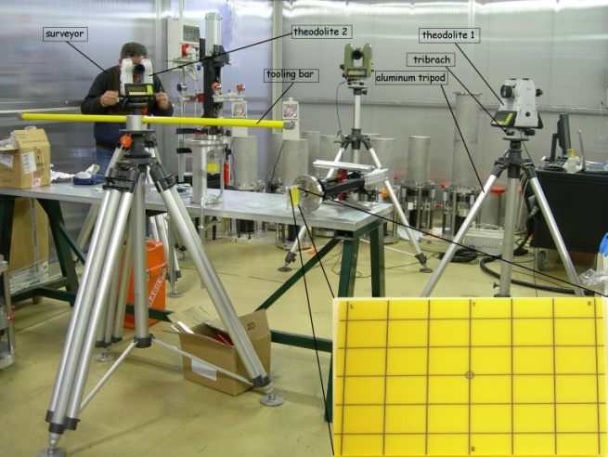
Figure 8: Setup for TV-screen qualification using two theodolites; at right a zoom of the serigraphy mask

Scintillating fiber harp
A Scintillating Fiber Harp (SFH) is the profile and low-bandwidth intensity beam monitor designed by Laboratoire Leprince-Ringuet (LLR-Paris) and installed along HEBT lines. The detector consists of 128 scintillating fibers in the horizontal plane and 128 in the vertical plane, covering an area of 64x64 mm². The signal of the fibers is acquired through a CCD firewire camera [11]. Detector and camera are mounted on a frame equipped with a pneumatic actuator (see Fig.9)
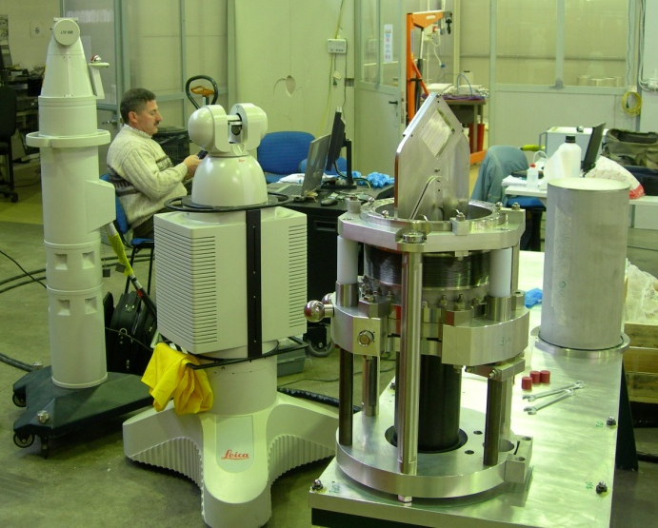
Figure 9: Setup for SFH qualification: LTD500 laser tracker, LR200 laser radar and the detector with CCD camera mounted on the frame.

The LR200 laser radar, the first non-contact measurement device to combine radar, laser and 3D software technologies with an accuracy up to 20 μm, has been the solution adopted for qualification of 24 SFH detectors. The instrument can scan all types of surface through a cloud of points. In the specific case is sufficient to scan 2 precise circular holes ϕ4 mm, the frame plane on which fibers are mounted and 6 spheres 1.5”. All data are acquired and analyzed by Spatial Analyzer (New River kinematics)[12].

ALIGNMENT
The accelerator alignment has been performed approximately in three and half years, using the Leica laser tracker system LTD500 and the software Axyz: LEBT in 2007; LINAC in 2008; MEBT and SYNC in 2009; HEBT from October 2009 till February 2010.
During this period network measurements revealed displacements and settlements of concrete slab in the order of magnitude of several millimeters. For planning reasons the installation could not be interrupted; so the followed strategy was to update network coordinates each time the best-fit of some points exceeds 0.1mm respect to previous set of coordinates.
Another alignment important issue is to adjust close magnets with a very high accuracy to one another. Therefore it is only be necessary to have a high accuracy in the neighbourhood. If neighbouring magnets are positioned on a smoothing curve systematic deviations between the nominal and the actual position is negligible. That’s the reason for which the same network references have been used for all the components (magnets and diagnostic) belonging to the same straight accelerator sector.
Except LEBT and LINAC, all the other accelerator sections are constituted of girders fixed on the floor, which give stiffness to the supported components. Furthermore, each magnet has its own regulation table, with three leveling screws independent of the transversal and longitudinal ones: this characteristic makes the alignment job easy and flexible.

CONCLUSIONS
Installation and alignment of all components are complete. Presently accelerator commissioning is ongoing and protons beam stored in SYNC [13]. Future activities on alignment network monitoring and, eventually, smooth alignment corrections are foreseen during accelerator shut down periods.

ACKNOWLEDGMENTS
The author wants to thank all the INFN-LNF survey technicians and the CNAO colleagues for their help and scientific support; T. Grasso (3D-HPM) for suggestions and help on high precision measurements; AXIST for its service during the alignment of SYNC and HEBT.

References
[1] Starplus Software, Inc. (2000). STARNET V6 least squares Survey Adjustment Program. Reference Manual; http://cobweb.ecn.purdue.edu/~bethel/sn6.pdf
[2] T. Biedermann, U. Fehlmann “The survey system LTD500 – Axyz”
[3] Robert E. Ruland “Setting reference targets” SLAC-Pub 7447, Stanford, USA April 1997
[4] F. Iungo, M. Modena, Q. Qiao, C. Sanelli, “DAΦNE magnetic measurements systems”, technical note MM-1, 4/11/1993; http://www.lnf.infn.it/user.html
[5] B. Bolli, N. Ganlin, F. Iungo, F. Losciale, M. Paris, M. Preger, C. Sanelli, F. Sardone, F. Sgamma, M. Troiani, “Comparison of magnetic and mechanical center positions of small quadrupoles and sextupoles in the DAΦNE main rings”, technical note MM-23, 19/03/1997
[6] C. Priano, G. Bazzano, D. Bianculli, E. Bressi, M. Pullia, L. Vuffray, I. De Cesaris, M. Buzio, D. Cornuet, R. Chritin, J. Dutour, C. Sanelli, E. Froidefond, “Magnetic modelling, measurements and sorting of the CNAO synchrotron dipoles and quadrupoles”, MOPEB004 IPAC’10, Kyoto, Japan
[7] G. Balbinot, J. Bosser, M. Caldara, A. Parravicini, “Harp monitor specifications”, CNA-SPDP-011WXX-03804, internal note, November 2004
[8] A. Parravicini, G. Balbinot, J. Bosser, E. Bressi, M. Caldara, L. Lanzavecchia, M. Pullia, M. Spairani, CNAO Foundation, Pavia, Italy – C. Biscari, LNF-INFN, Frascati, Italy, “Beam Diagnostics in the CNAO injection lines commissioning”, HIAT 2009
[9] G. Balbinot, J. Bosser, D. Bianculli, M. Caldara, A. Parravicini, “Synchrotron pickups alignment”, CNA-TNDF-011WXX-04243, internal note, March 2010
[10] G. Balbinot, J. Bosser, M. Caldara, A. Parravicini, “TV screen system technical specifications”, CNA-SPDP-011WXX-03807, internal note, February 2008
[11] G. Balbinot, J. Bosser, M. Caldara, A. Parravicini, “Scintillating fibers harp monitor technical specifications”,CNA-SPDF-011WXX-04214, January 2007
[12] New River Kinematics - Spatial Analyzer http://www.kinematics.com/products/spatialanalyzer/overview.html
[13] G. Bazzano, “Status of the commissioning of the Centro Nazionale di Adroterapia Oncologica (CNAO)”, MOPEB005 IPAC’10, Kyoto, Japan

